**Installation Anaconda**

**Step1:**

open any web browser for example open google chrome type anaconda download

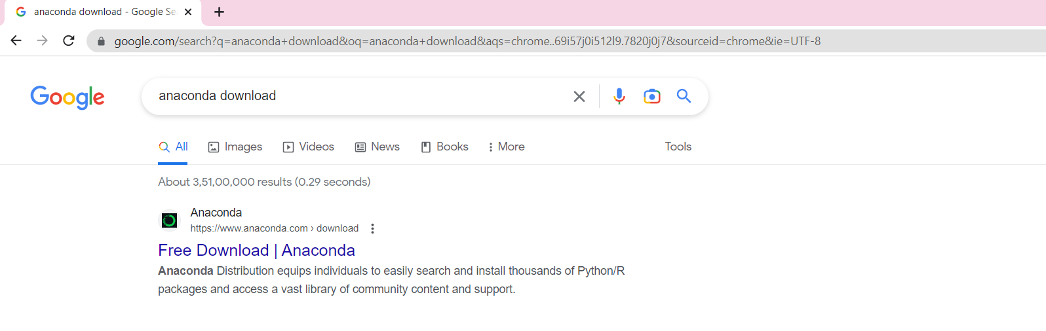**Step2:** 

Click on free download like shows above figure, then the page will be redirected to shown as below figure.

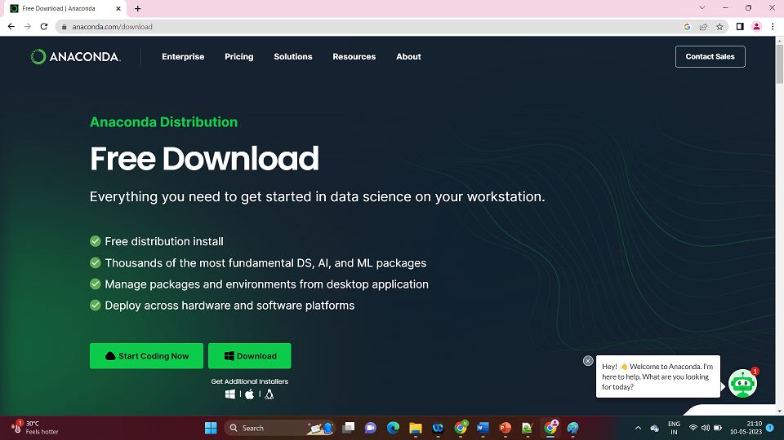



**Step3:**

Click on download button like shown above figure it will be redirected to download page its show as below figure.

**Step4:**

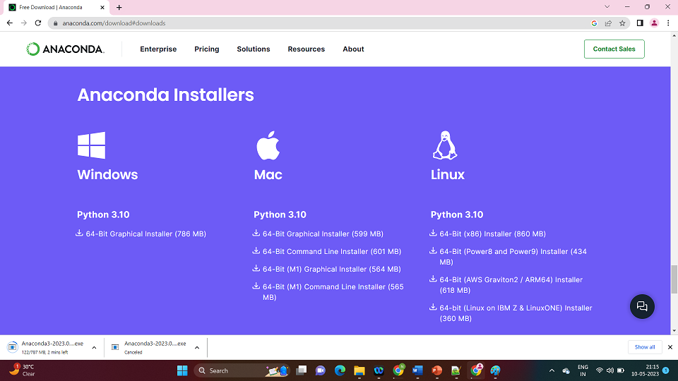we can see anaconda exe file downloading

**Step-5:**

now you can open the exe file to install anaconda, the exe file will be in downloads

**Step-6:**

when you open the exe file a dialogue box will open like below figure, click on next

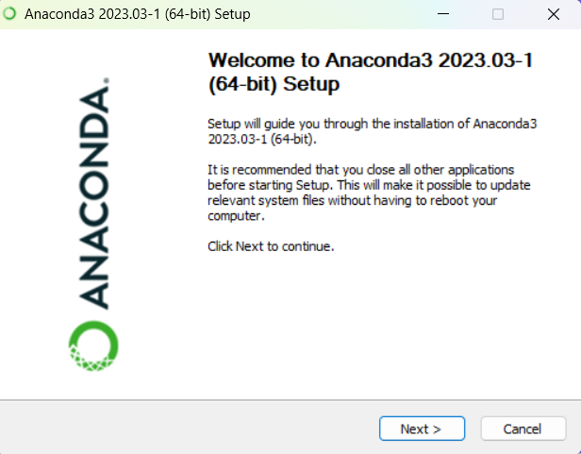

**Step-7:**

When you click on next it will be redirected to another dialogue box like shown below figure 

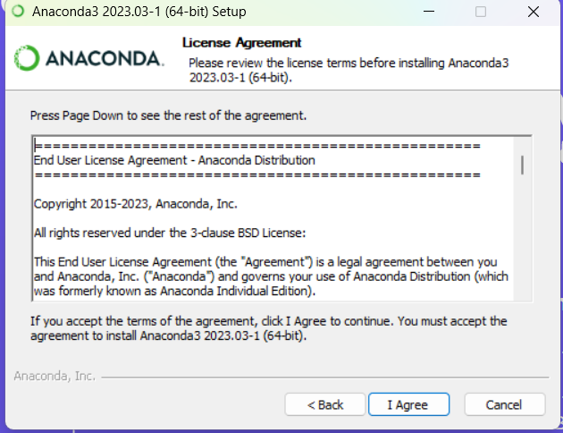

**Step-8:**

Click on I agree then select just me(recommend) and click on the next button

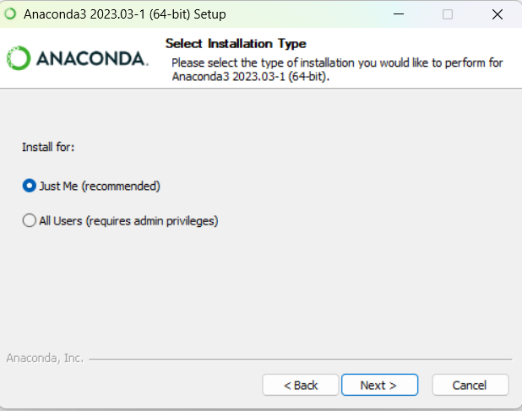

**Step-9:**

if you want change the destination folder or keep it is as it is

generally it takes c:\\users\<name_of_the_user>\anaconda3

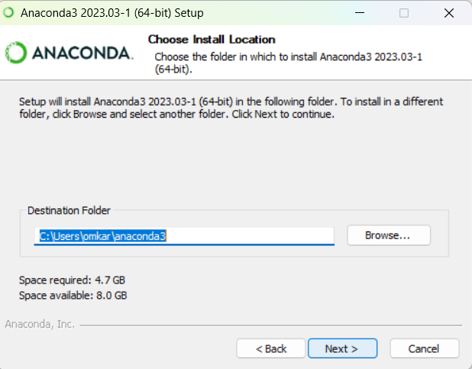

**Step-10:**

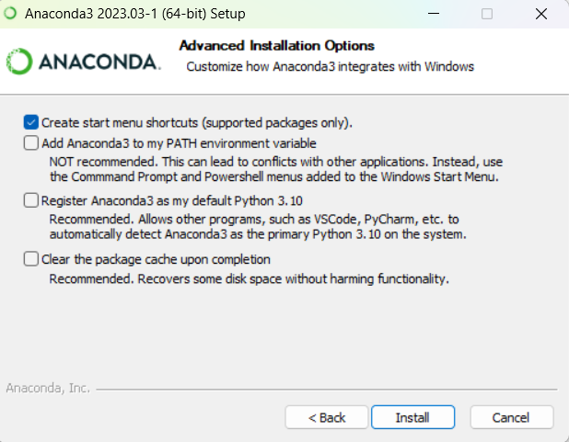 just click on install button



**Step-11:**

Just wait for some time till the green line complete



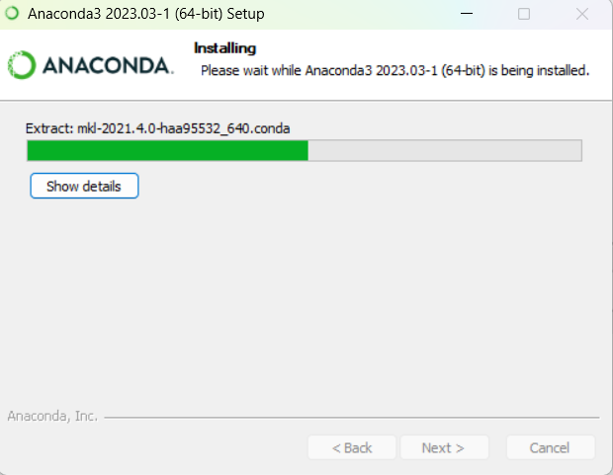

**Step-12:**

Below figure shows how the installation complete, then click on next

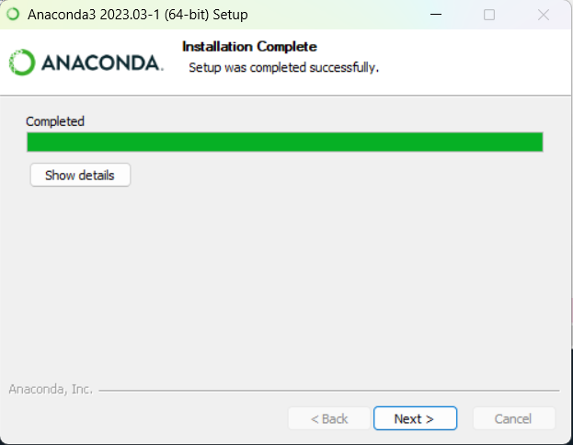





**Step-13:**

Click on next

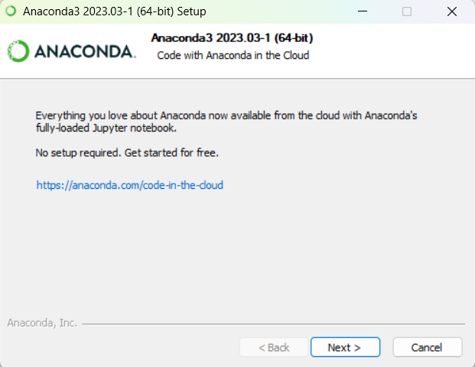 

**Step-14:**

Click on finish

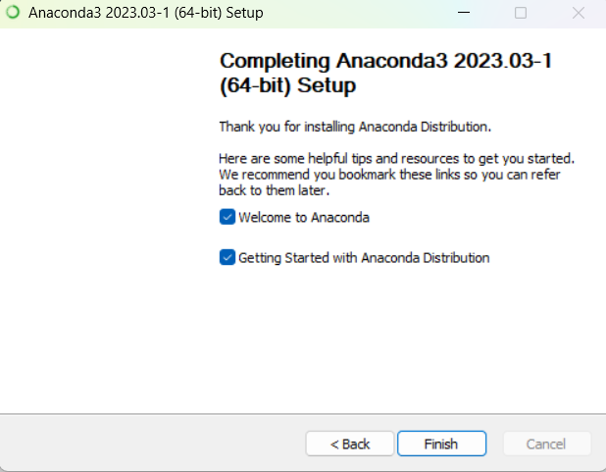



**Step-16:**

Search Anaconda navigator in search bar, click on open

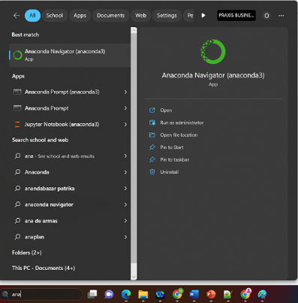

**Step-17:**

It will take few minutes to open, while opening you can see a anaconda intialization symbol like below



**Step-18:**

Ones it is opened you can see the anaconda initialization symbol in task bar, click on that you will see a anaconda navigator application,

Next search for Jupyter note book click on launch

Note**:

If under jupyter note book if you see install, then first install it. Then you will see launch

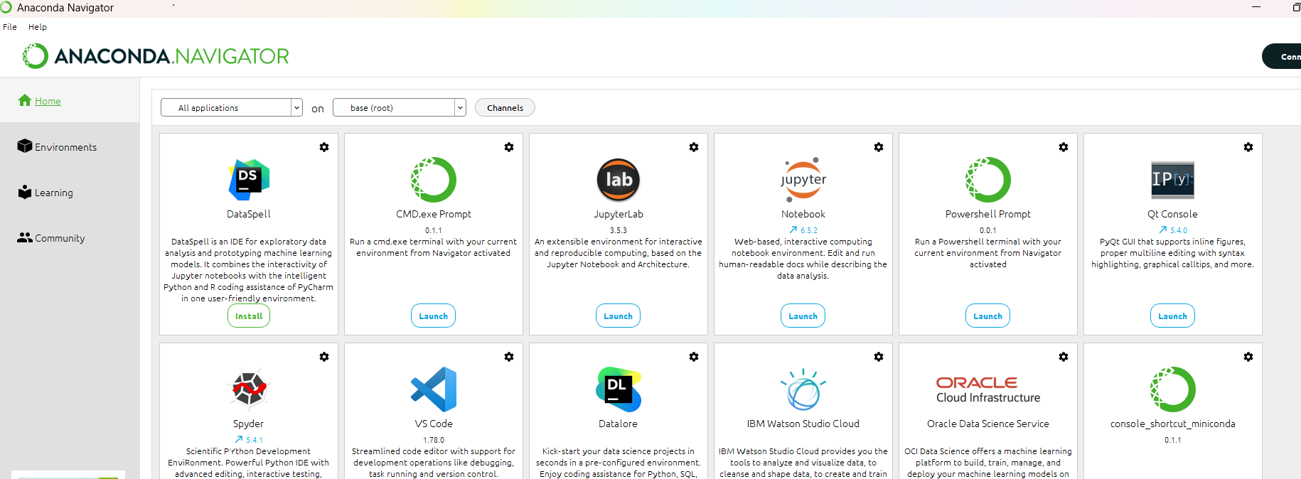

**Step-19:**

Ones you launch jupyter notebook , a jupyter interface will open web browser either edge or chrome

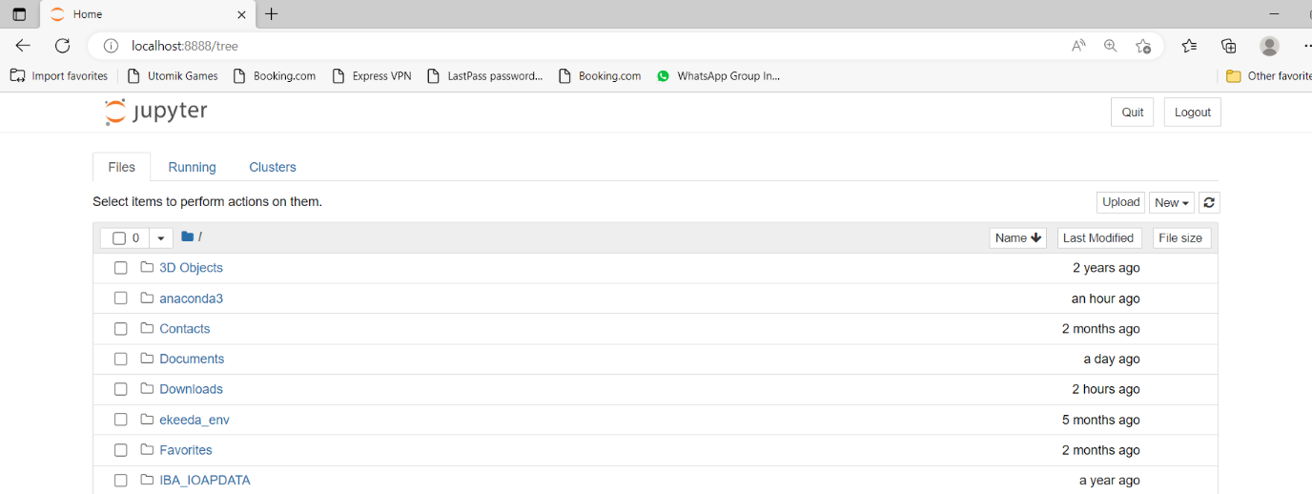

**Step-20:**

Click on new icon it’s on top right corner like shown in above figure, a new == > Python 3

A python notebook will open

